**Ansible**

How to install ansible

Step 1:

Start application

To start the application first we need to create instances in AWS -ec2 instances

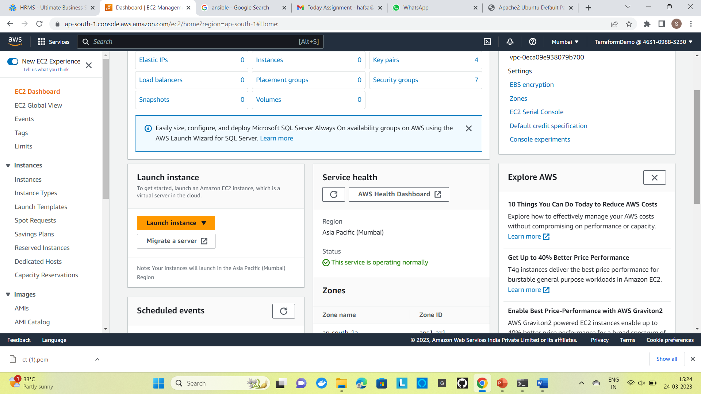

Step 2:

Create a instance and generate a new key pair

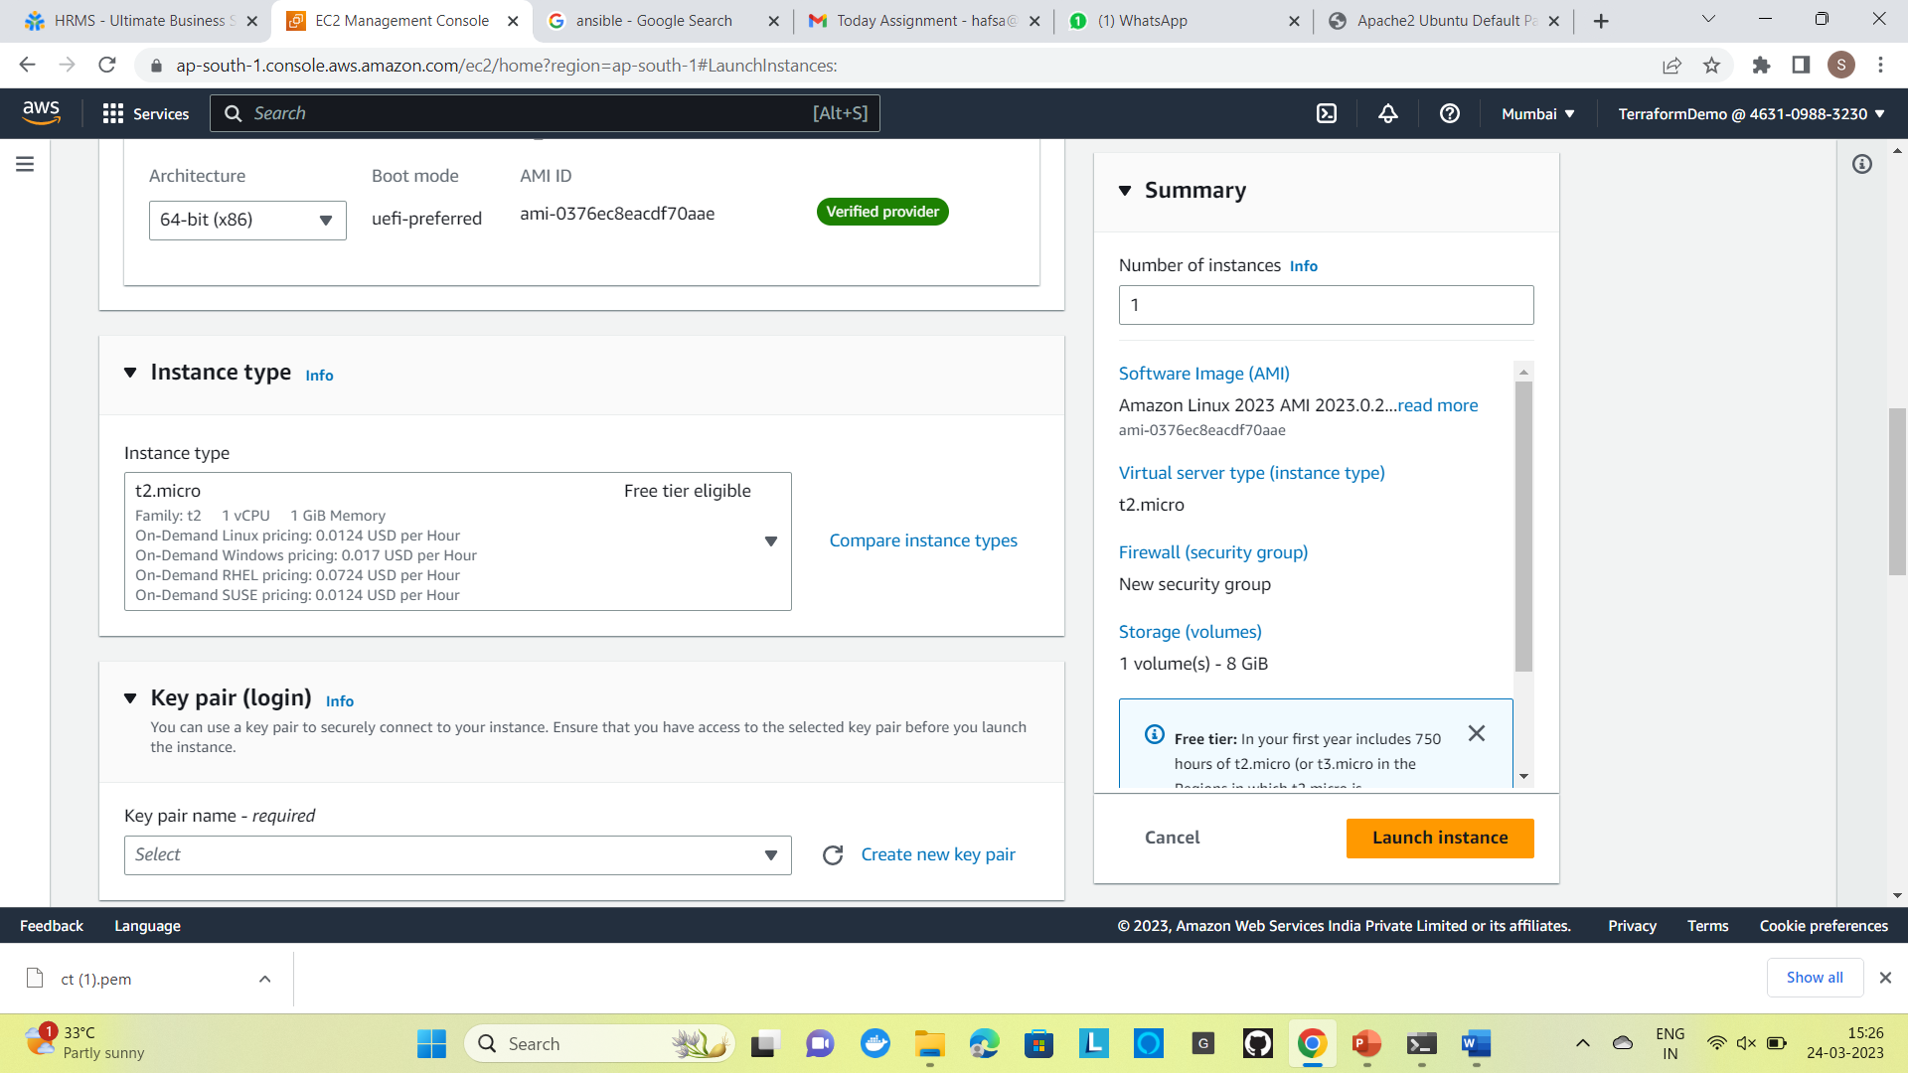

We have created 2 instances by using ansible

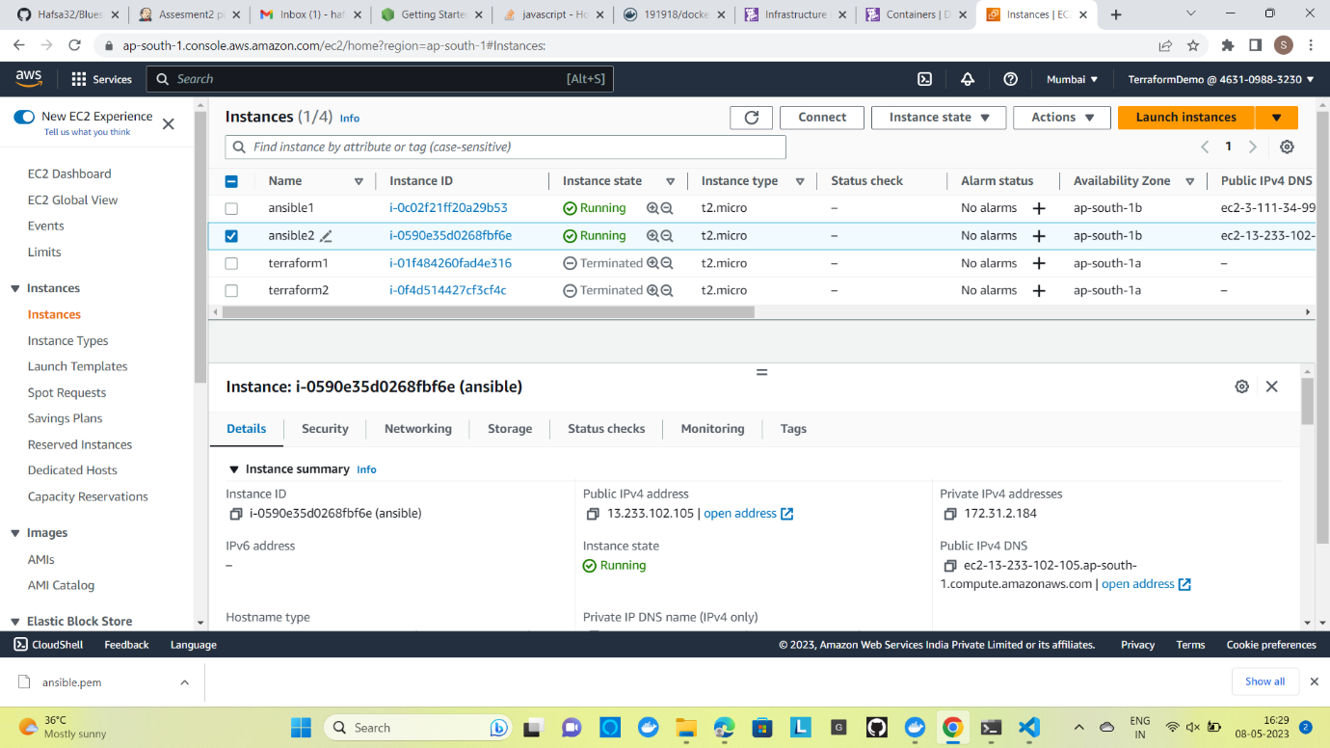

Step 3:

Connecting the instances

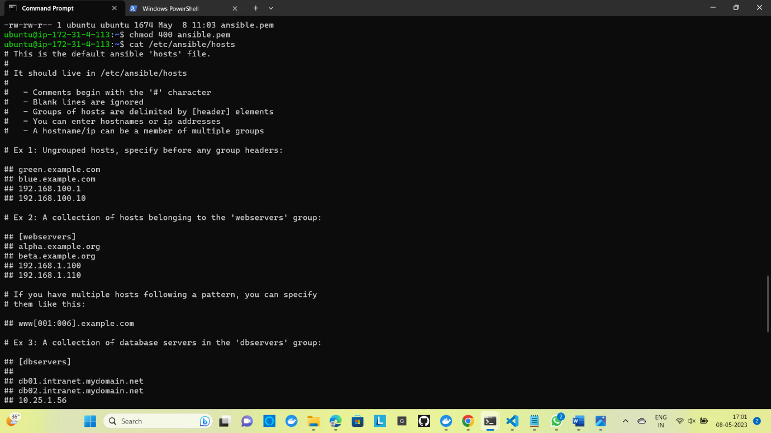

Step 4:

ubuntu@ip-172-31-38-64:~ $ Installing ansible

ubuntu@ip-172-31-4-113:~$ sudo apt-add-repository ppa:ansible/ansible

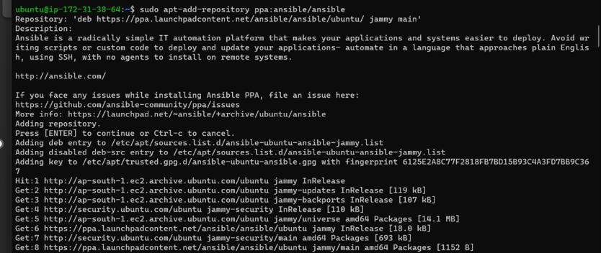

Step 6:

ubuntu@ip-172-31-38-64:~$ sudo apt update

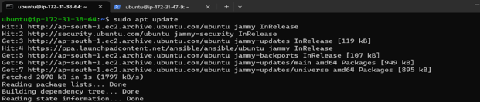

Step 7:

ubuntu@ip-172-31-4-113:~$ sudo apt install ansible

ubuntu@ip-172-31-38-64:~$sudo vi /etc/ansible/hosts

Step 9:

ubuntu@ip-172-31-38-64:~$ ansible all -m ping

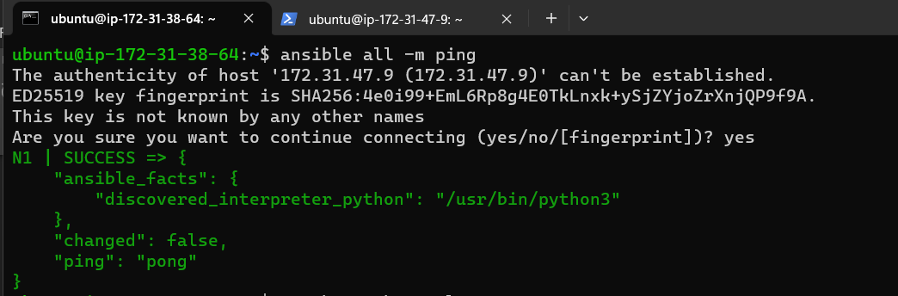

Step 10:

ubuntu@ip-172-31-38-64:~$ touch apache.yaml

Creates a new apache.yaml file

ubuntu@ip-172-31-38-64:~$ sudo vi apache.yaml

ubuntu@ip-172-31-38-64:~$ ansible-playbook apache.yaml

